Introduction to RAG (Retrieval Augmented Generation) and Vector Database



Sachin Soni
Follow
8 min read
·
Sep 15, 2024
80
3
Retrieval-Augmented Generation (RAG) is a powerful technique that enhances the capabilities of language models by combining two key processes: retrieving information and generating text. While traditional language models like GPT rely only on what they were trained on, RAG goes a step further by searching for relevant information from external sources, like a database or documents, to help generate more accurate and detailed answers. This makes RAG especially useful in tasks where up-to-date or specialized knowledge is needed, such as answering questions or generating informative content.
Press enter or click to view image in full size
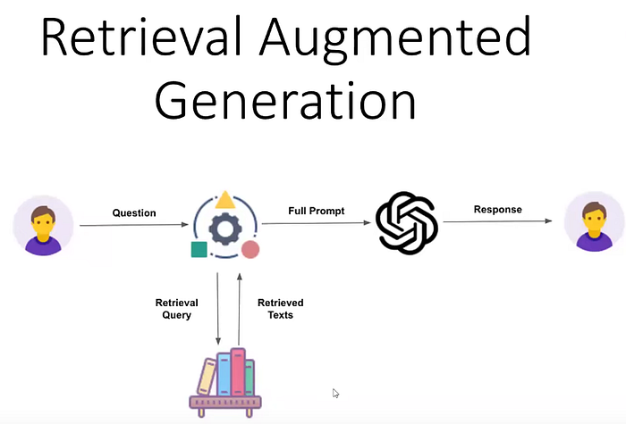
image by CampusX

Limitations of Large Language Models Before RAG :
Large Language Models (LLMs) like GPT-3 have impressive capabilities, but they come with several key limitations:
- Outdated Knowledge: LLMs can’t access new information after they’re trained. They rely only on the data they were trained with, so they can’t provide real-time or up-to-date information.
- Factual Mistakes: LLMs can generate fluent text but sometimes give incorrect or misleading answers, especially on less common or specialized topics.
- Hallucination Problem: LLMs sometimes “hallucinate,” meaning they confidently generate information that sounds reasonable but is completely false. This happens because they rely only on patterns from their training data rather than real-time information.
- No Access to External Information: LLMs can’t look up answers from external sources, like the internet or a database, which limits their ability to provide specific or accurate details on certain topics.

How RAG Solves These Issues
Retrieval-Augmented Generation (RAG) helps solve many of these problems by allowing LLMs to fetch relevant information from external sources. Instead of relying solely on their internal knowledge, RAG models can search databases or documents for real-time, up-to-date information, which helps reduce hallucinations and improves the accuracy of generated content. By integrating retrieval, RAG ensures that the model generates more reliable, fact-based answers, even for specialized or complex queries.

Understanding Information Retrieval Before RAG
Before diving into Retrieval-Augmented Generation (RAG), it’s crucial to understand Information Retrieval (IR), which plays a foundational role. As the name suggests, information retrieval is about finding and extracting relevant data from large datasets. Think of it like this: when we were kids, we used to answer questions based on a given paragraph. We didn’t use the entire paragraph; instead, we picked the exact information needed to answer the question. This is the essence of IR — retrieving only the relevant information from massive collections, which could be text, images, audio, or even video.
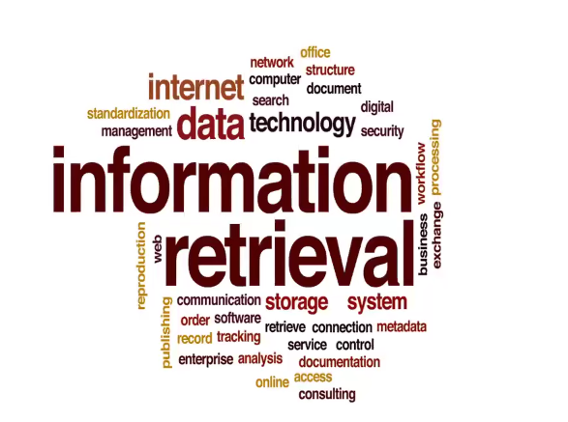
image by CampusX
The process of IR generally consists of a few key steps, the first of which is indexing. Indexing involves converting external data sources into numerical representations, making it easier to search through large datasets. For example, if you’re looking for information on the “ICC Cricket World Cup 2023,” IR systems will scan through the database and rank all related documents, prioritizing the ones that contain the most relevant information.

Workflow of RAG :
In Retrieval-Augmented Generation (RAG), the workflow revolves around three main components: Retrieve, Augment, and Generate. Here’s a detailed breakdown of each phase:

1. Retrieve
This phase is responsible for fetching relevant information from an external knowledge base, database, or document repository. The process begins with a query, usually derived from the user’s input or a given prompt.
- Embedding Model: The input query is first converted into vector embeddings using an embedding model. This model maps the input into a numerical form that can be used for similarity searches.
- Vector Database: Once the query is embedded, it is sent to a Vector DB, which contains embeddings of documents, text data, or any relevant external information. This database is indexed based on vector similarity (cosine similarity is often used).
- Retriever & Ranker: A retriever component then selects the top N documents or relevant data points based on similarity. These documents are ranked in order of relevance, typically using semantic search or other retrieval algorithms like sparse or dense retrieval methods.

2. Augment
In this phase, the retrieved information is used to provide additional context to the query or prompt, enhancing the model’s understanding of the task.
- Retrieved Context: The top N documents fetched in the retrieval stage are passed back to the model as retrieved context. This information is appended or "augmented" with the original user query to provide additional details and improve the relevance and accuracy of the response.
The goal here is to leverage both the external knowledge base and the model’s trained knowledge to handle specific or unseen questions better.
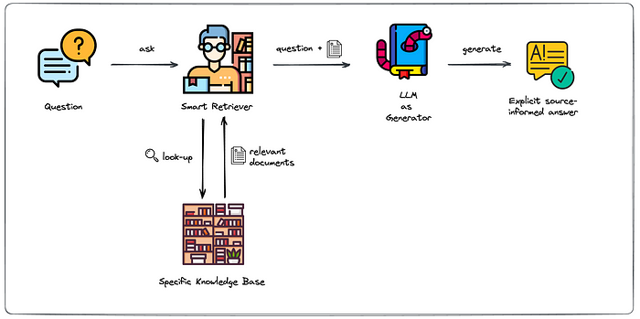
image Source

3. Generate
The final stage is responsible for generating the actual output, which combines the original prompt/query with the augmented data from the retrieval phase.
- LLMs (Large Language Models): The augmented prompt, along with the retrieved context, is passed to the LLMs (e.g., GPT, BERT, or any transformer-based model). The LLMs processes the input and generates a response that is more context-aware and accurate, thanks to the extra information it received from the retrieval phase.
- Formatted Response: The output is returned as a formatted response, usually displayed in the user interface. The user query is enriched with additional, often domain-specific or up-to-date, information, addressing some of the inherent limitations of standard language models.

Visualizing the RAG Workflow:
The below diagram outlines the Retrieval-Augmented Generation (RAG) framework, showing how it integrates retrieval methods with a generative approach to improve text generation.
Press enter or click to view image in full size
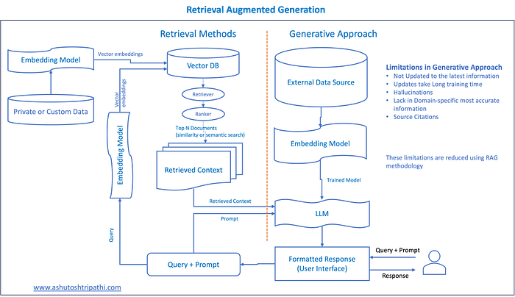
image Source

Explanation of Above diagram workflow :

A. Left Side (Retrieval Methods)
- Private or Custom Data:
- This represents a large corpus of documents or information that may not be part of the trained model (such as private databases, custom datasets, or any source of external knowledge).
2. Embedding Model:
- An embedding model (like BERT, or Sentence Transformers) is used to convert the documents and the user’s query into dense vector representations (embeddings). These vectors represent the semantic meaning of the documents and queries in high-dimensional space.
3. Vector DB:
- The embeddings are stored in a Vector Database, which allows for efficient similarity search. When a query is issued, the database retrieves the documents based on their vector similarity to the query.
4. Retriever and Ranker:
- Retriever: When a query is provided, the retriever pulls the top N most relevant documents (based on vector similarity).
- Ranker: The ranker ranks these documents based on relevance (using similarity measures like cosine similarity).
. Retrieved Context:
- The top N most relevant documents or pieces of text are selected as the retrieved context to be used by the generative model in the next step.

B. Right Side (Generative Approach)
- External Data Source:
- This highlights the limitation of purely generative models (such as LLMs) that do not have access to new or external data beyond their training corpus. They may:
- Not be up-to-date.
- Suffer from hallucinations.
- Lack specific domain knowledge.
2. Embedding Model:
- This step represents how the query and retrieved documents are encoded into embeddings to be processed by the generative model (e.g., LLMs).
3. LLMs (Large Language Model):
- The LLMs (like GPT, BART, T5, etc.) takes the retrieved context (from the left side of the diagram) along with the original query and generates a response. This helps to improve the factual accuracy of the output by integrating external, relevant documents.
4. Formatted Response (User Interface):
- The user receives the final output, which is more informed and factually correct, as it integrates both generative capabilities and retrieved information.
So far, we have covered the basics of RAG. Now, let’s delve into the concept of Vector Databases.

Understanding Vector Databases :
In today’s digital landscape, when you perform a search on Google, such as “calories in apple” versus “employees in Apple,” the search engine cleverly distinguishes between the fruit and the company. But have you ever wondered how Google achieves this? The answer lies in a technique known as semantic search.
Semantic search moves beyond simple keyword matching to understand the intent behind a user’s query and leverage context for more accurate results. At its core, semantic search relies on the concept of embeddings — numerical representations of text.

What Are Embeddings ?
Embeddings transform words or sentences into numeric vectors. For instance, consider the word “Apple.” In one context, it could refer to the fruit, while in another, it might denote the tech company. To represent this, we create a vector that encodes features related to each context. For “Apple” the fruit, the vector might reflect attributes like “fruit,” “sweet,” and “edible.” For “Apple” the company, the vector would focus on “technology,” “company,” and “innovation.”
Press enter or click to view image in full size
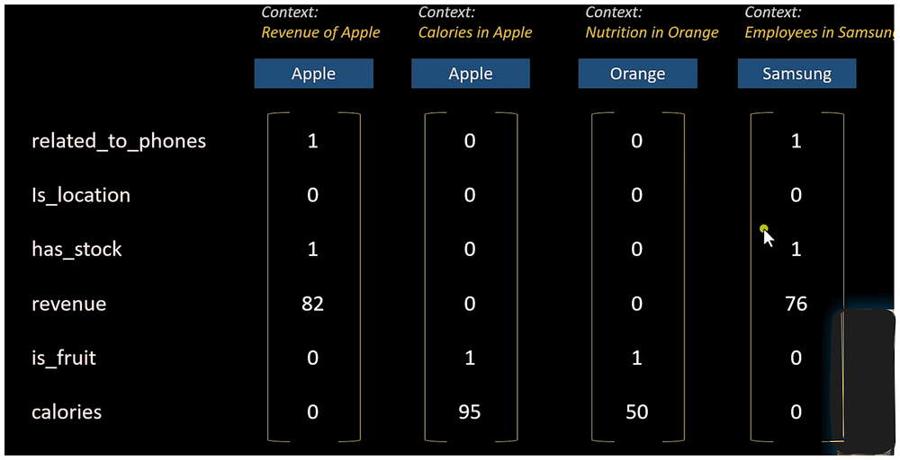
image Source
These vectors allow us to capture the semantic similarity between words. For example, the vectors for “Apple” and “orange” might show similarities in their fruit-related attributes, while vectors for “Apple” and “Samsung” would highlight their similarities in the tech context.

The Role of Vector Databases :
With thousands or even millions of embeddings to manage, storing and searching these vectors efficiently becomes crucial.
Press enter or click to view image in full size
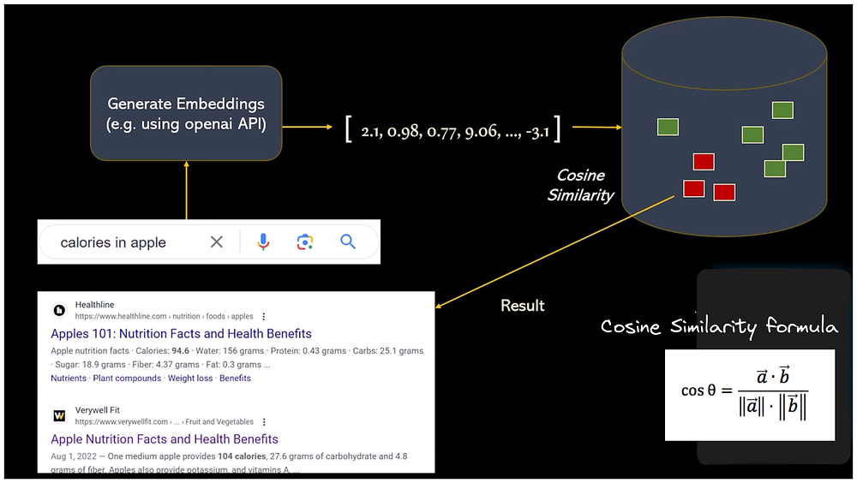
image Source
Traditional relational databases might initially seem like a viable option. You’d generate embeddings, store them in a SQL database, and then compare new query embeddings to retrieve relevant results. However, this approach struggles with scalability and efficiency when dealing with vast amounts of data.
Press enter or click to view image in full size
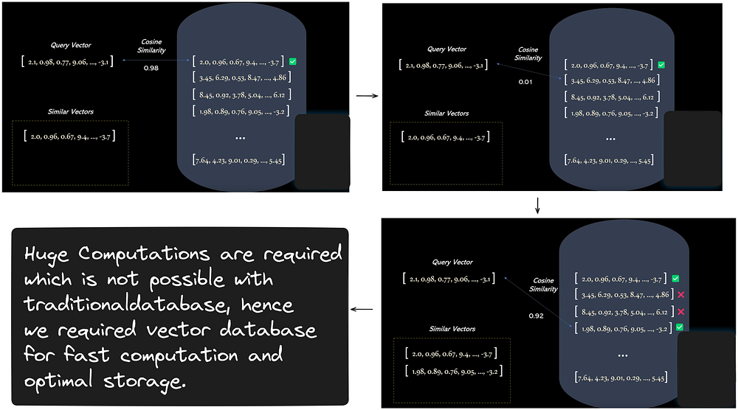
image Source
To address these challenges, vector databases come into play. They are optimized for storing and querying large-scale vector embeddings. Instead of linear search, which is computationally expensive and slow for large datasets, vector databases use techniques like indexing and locality-sensitive hashing (LSH) to speed up searches.

Locality Sensitive Hashing (LSH) :
LSH is a technique that partitions vectors into “buckets” based on their similarity. When a search query is performed, it is hashed into one of these buckets, significantly reducing the number of comparisons needed. Instead of comparing the query vector with every stored vector, you only need to compare it with those in the same bucket. This method accelerates search times and enhances efficiency.
Press enter or click to view image in full size
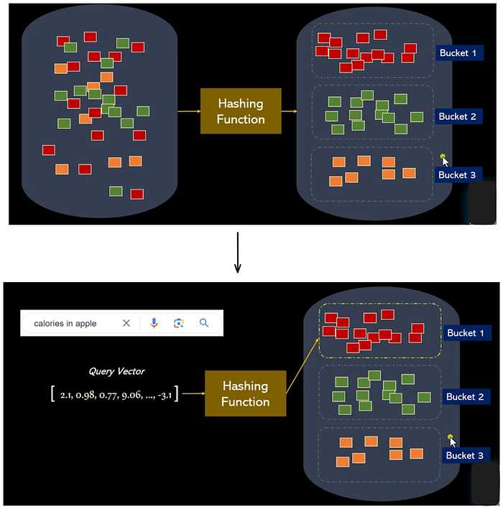
image Source

Why Vector Databases?
Vector databases offer two primary benefits:
- Faster Searches: By employing techniques like LSH, they can rapidly locate relevant vectors.
- Optimal Storage: They are designed to handle the unique requirements of vector data, ensuring efficient storage and retrieval.
As vector databases continue to evolve, they are becoming increasingly essential for applications involving semantic search, recommendation systems, and more.
I hope this overview helps you understand the fundamentals of vector databases and their significance in modern data retrieval and search technologies.

References :
Research Paper for RAG : Retrieval-Augmented Generation for Large Language Models: A Survey
Vector Database Youtube Video: https://youtu.be/72XgD322wZ8?si=KPFg30be_EBu7EUa
Vector Database Article : https://www.pinecone.io/learn/vector-database/
I trust this blog has enriched your understanding of Retrieval Augmented Generation(RAG). If you found value in this content, I invite you to stay connected for more insightful posts. Your time and interest are greatly appreciated. Thank you for reading!

